Ideation Phase
Define the Problem Statement

Date | 25 November 2025
Team ID
Project Name | BookStore
Maximum Marks | 2 Marks

Problem statement:
Customers often struggle to find the books they want due to cluttered catalogs, limited search options, and inconsistent product information across online bookstores. They face difficulty comparing books, reading reliable reviews, and discovering relevant recommendations. On the other hand, administrators and store owners find it hard to manage book inventory, update listings, track orders, and maintain categories efficiently because of outdated or scattered systems. This results in frustration for readers, inefficiency for admins, and a poor overall browsing and purchasing experience. BookSpot aims to solve these issues by offering a clean, organized, and user-friendly online bookstore with powerful search, personalized recommendations, and efficient admin controls.

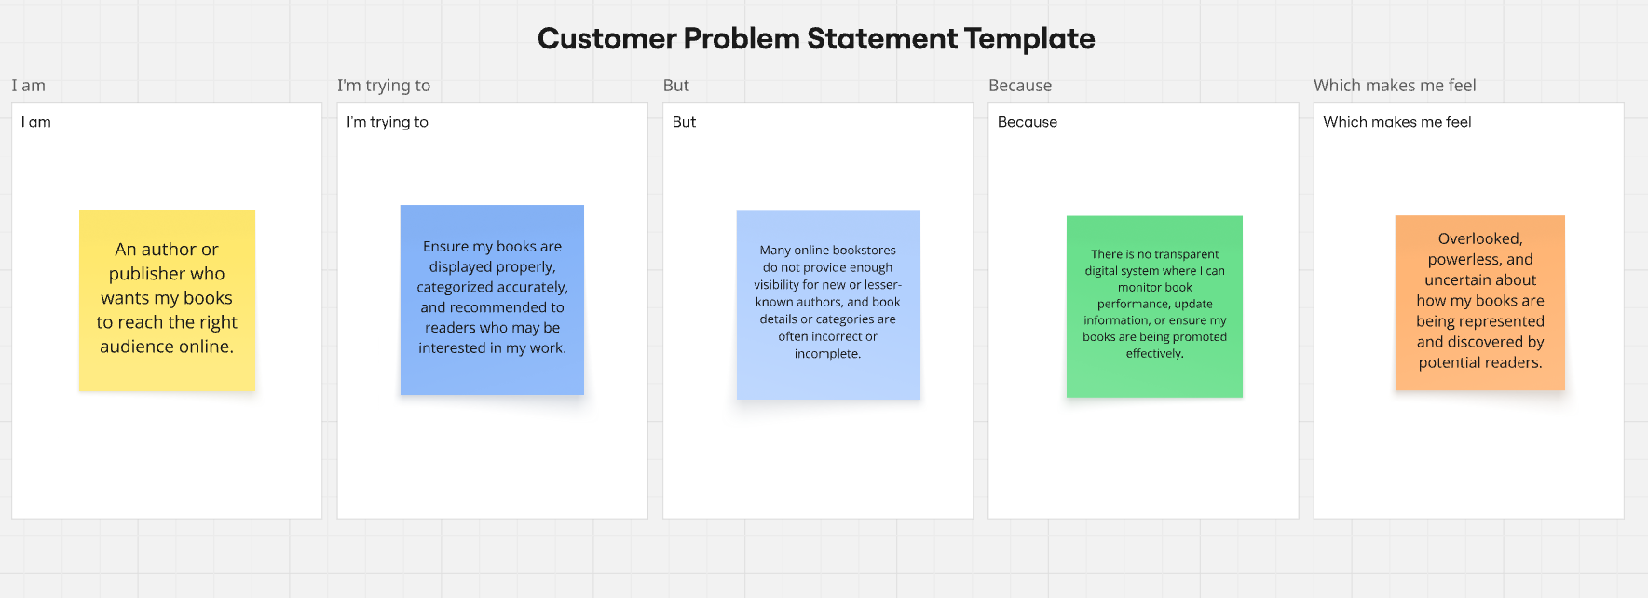

Customer Problem Statement 1: User
I am
A reader looking for an easy and enjoyable way to discover and buy books online.
I’m trying to
Search for books by genre, author, or title, compare options, read reviews, and purchase without confusion or delays.
But
Most online platforms have cluttered layouts, limited filters, or outdated listings that make it hard to find the right book quickly.
Because
There is no unified, well-organized digital store that offers accurate book details, personalized suggestions, or a smooth checkout flow.
Which makes me feel
Frustrated, overwhelmed, and unsure about which book to buy or where to find reliable information.

Customer Problem Statement 2: User
I am
An admin responsible for managing the bookstore catalog and customer orders.
I’m trying to
Add and update books easily, organize categories, track orders, and keep the inventory up to date.
But
Existing systems are fragmented, time-consuming, and require manual updates that lead to errors or inconsistencies.
Because
There is no centralized and intuitive admin dashboard that simplifies book management and automates routine tasks.
Which makes me feel
Overloaded, inefficient, and unable to maintain a clean and reliable bookstore experience for users.

